ARTIFICIAL INTELLIGENCE
Assignemnt 1
Jay Vankar
U24AI042
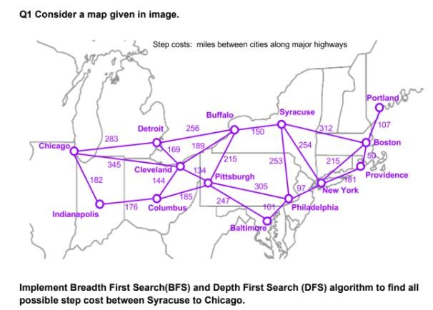
BFS:
from collections import deque

def bfs_all_paths_costs(graph, start, goal):
queue = deque()
queue.append((start, [start], 0)) # (node, path, cost)
results = []
price=0

while queue:
current, path, cost = queue.popleft()

if current == goal:
results.append((path, cost))
# don't break — we want *all* paths

# expand neighbors breadth-first
for neighbor, step_cost in graph[current].items():

if neighbor not in path: # avoid cycles
price=price+ step_cost
queue.append(( neighbor, path + [neighbor],price ))

return results

# Define the graph
graph = {
"Chicago": {"Detroit": 283, "Cleveland": 345, "Indianapolis": 182},
"Detroit": {"Chicago": 283, "Cleveland": 169, "Buffalo": 256},
"Cleveland": {"Detroit": 169, "Pittsburgh": 134, "Columbus": 144, "Chicago": 345, "Buffalo": 189},
"Columbus": {"Cleveland": 144, "Indianapolis": 176, "Pittsburgh": 185},
"Indianapolis": {"Chicago": 182, "Columbus": 176},
"Pittsburgh": {"Cleveland": 134, "Buffalo": 215, "Philadelphia": 305, "Columbus": 185, "Baltimore": 247},
"Buffalo": {"Detroit": 256, "Pittsburgh": 215, "Syracuse": 150, "Cleveland": 189},
"Syracuse": {"Buffalo": 150, "New York": 254, "Boston": 312, "Philadelphia": 253},
"New York": {"Syracuse": 254, "Philadelphia": 97, "Boston": 215, "Providence": 181},
"Philadelphia": {"New York": 97, "Pittsburgh": 305, "Baltimore": 101, "Syracuse": 253},
"Baltimore": {"Philadelphia": 101,"Pittsburgh":247},
"Boston": {"Syracuse": 312, "Providence": 50, "New York": 215, "Portland": 107},
"Providence": {"Boston": 50, "New York": 181},
"Portland": {"Boston": 107}
}

bfs_results = bfs_all_paths_costs(graph, "Syracuse", "Chicago")
count=0
print("\nBFS Paths & Costs:")
for path, cost in bfs_results:
print(path, "=>", cost)
count=count+1
print(count)

OUTPUT:
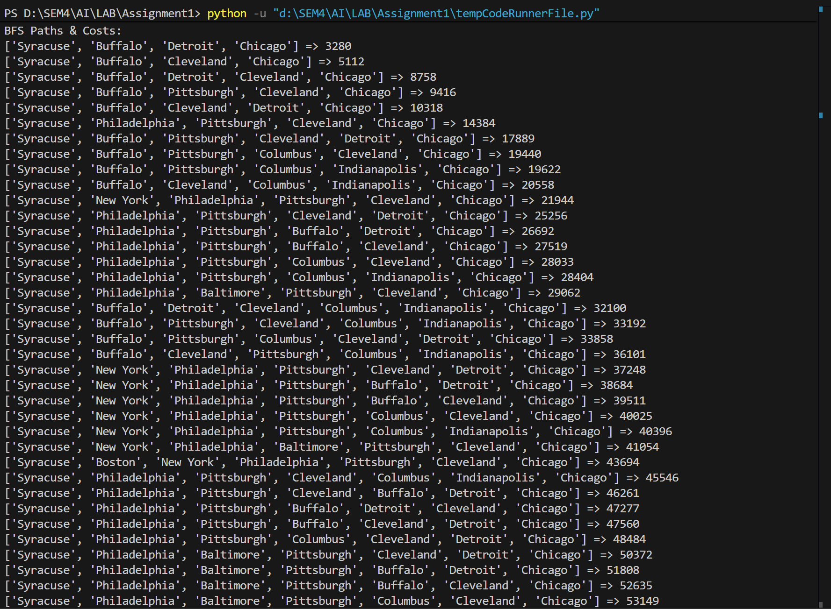
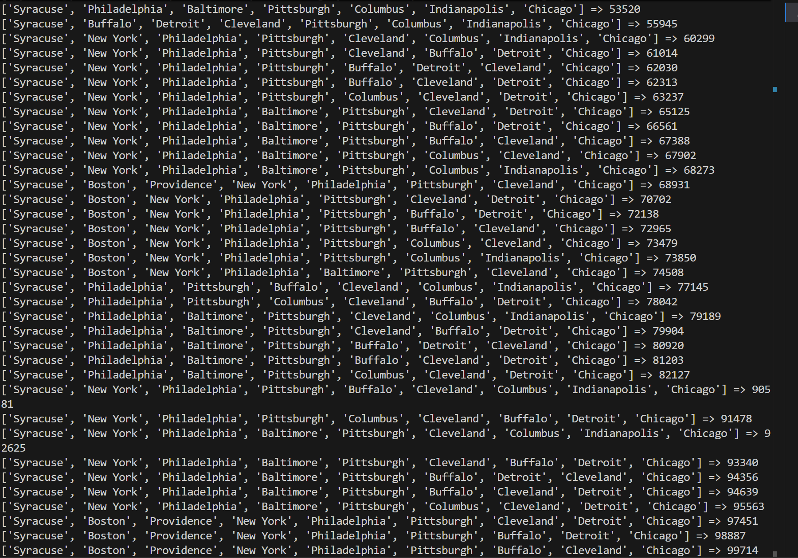
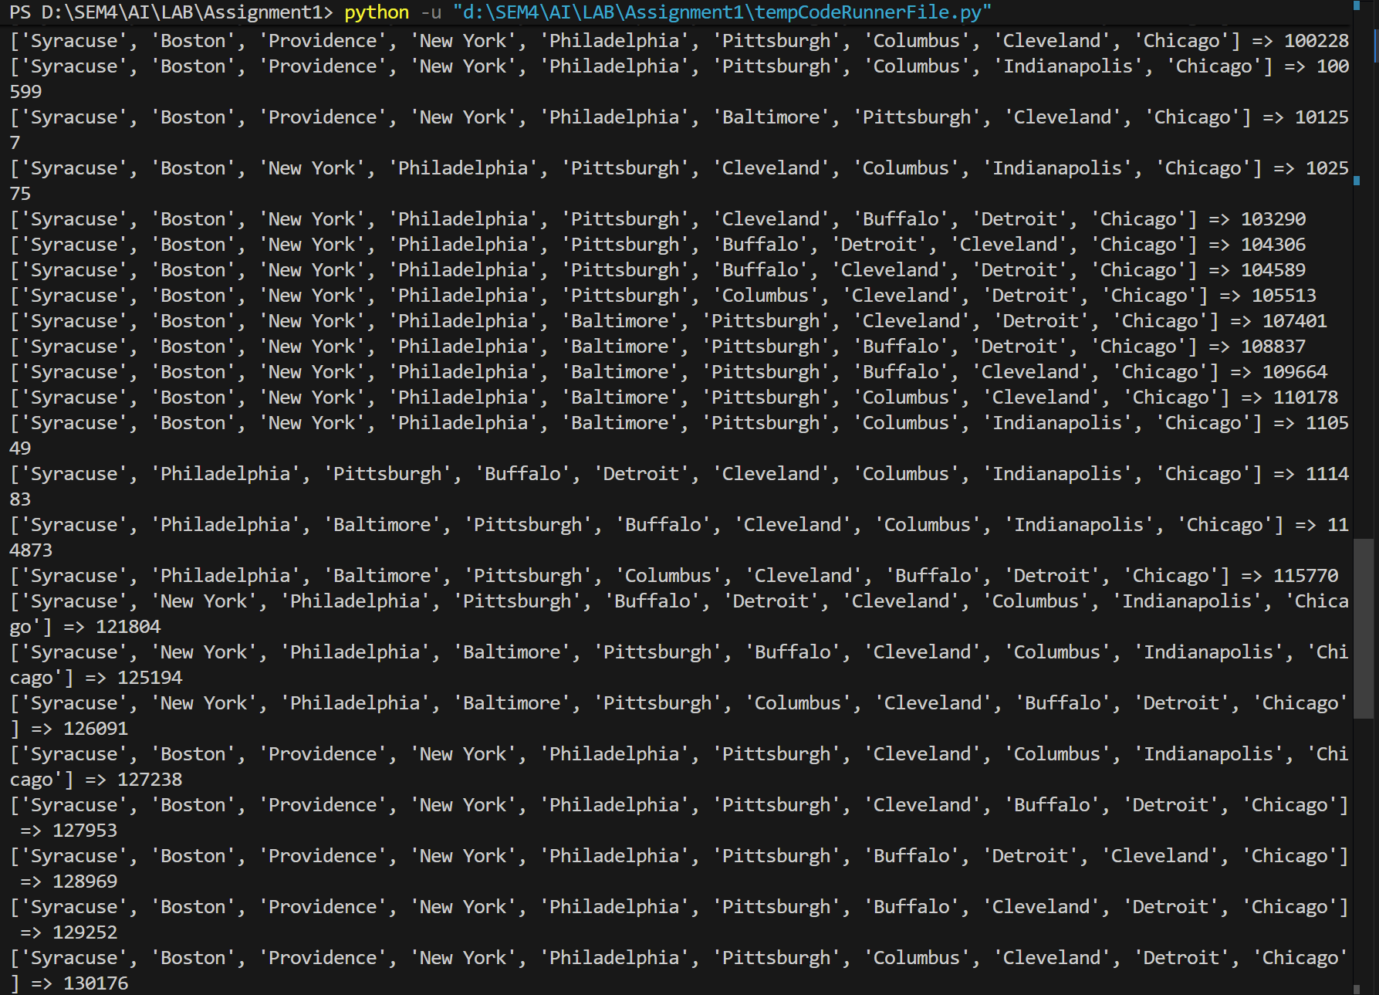

DFS:
graph = {
"Chicago": {"Detroit": 283, "Cleveland": 345, "Indianapolis": 182},
"Detroit": {"Chicago": 283, "Cleveland": 169, "Buffalo": 256},
"Cleveland": {"Detroit": 169, "Pittsburgh": 134, "Columbus": 144, "Chicago": 345},
"Columbus": {"Cleveland": 144, "Indianapolis": 176, "Pittsburgh": 185},
"Indianapolis": {"Chicago": 182, "Columbus": 176},
"Pittsburgh": {"Cleveland": 134, "Buffalo": 215, "Philadelphia": 305, "Columbus": 185},
"Buffalo": {"Detroit": 256, "Pittsburgh": 215, "Syracuse": 150},
"Syracuse": {"Buffalo": 150, "New York": 254, "Boston": 312},
"New York": {"Syracuse": 254, "Philadelphia": 97, "Boston": 215},
"Philadelphia": {"New York": 97, "Pittsburgh": 305, "Baltimore": 101},
"Baltimore": {"Philadelphia": 101},
"Boston": {"Syracuse": 312, "Providence": 50, "New York": 215, "Portland": 107},
"Providence": {"Boston": 50},
"Portland": {"Boston": 107}
}

start = "Syracuse"
target = "Chicago"

#DFS
def stuck(x, seen): #Check if from city x, there is still a path to the target
if x == target:
return False
for y in graph[x]:
if y not in seen:
seen.add(y)
if not stuck(y, seen):
return False
return True

def search(path): #search for the path
x = path[-1]
if x == target:
dis = 0
for i in range(len(path) - 1):
dis += graph[path[i]][path[i+1]]
print(" -> ".join(path), f" Total Distance: {dis} miles")
return

seen = set(path)
if stuck(x, set(seen)):
return

for y in graph[x]:
if y not in path:
path.append(y)
search(path)
path.pop()

print(f"All possible paths from {start} to {target}:\n")
search([start])

Output:
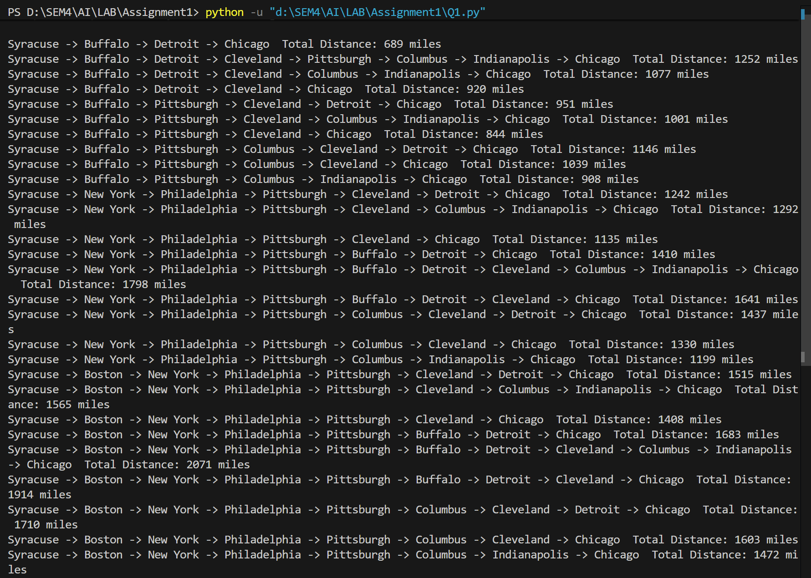

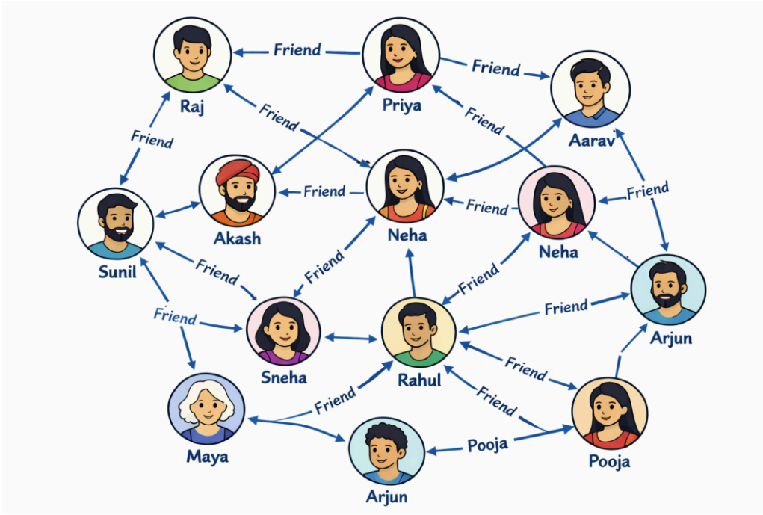
Code:
BFS:
graph = {
"Raj": ["Sunil", "Neha_1"],
"Sunil": ["Raj", "Akash", "Sneha", "Maya"],
"Akash": ["Sunil", "Priya"],
"Priya": ["Raj", "Aarav", "Akash"],
"Neha_1": ["Raj", "Akash", "Sneha", "Aarav"],
"Sneha": ["Sunil", "Neha_1", "Rahul"],
"Maya": ["Rahul", "Arjun_1", "Sunil"],
"Aarav": ["Neha_1", "Arjun_2"],
"Neha_2": ["Priya", "Neha_1", "Rahul", "Arjun_2"],
"Rahul": ["Neha_1", "Neha_2", "Sneha", "Maya", "Pooja", "Arjun_2"],
"Arjun_1": ["Maya", "Pooja"],
"Arjun_2": ["Aarav", "Neha_2", "Rahul"],
"Pooja": ["Arjun_1", "Arjun_2", "Rahul"]
}

from collections import deque
#BFS
def bfs_tree(graph, start):
visited = set([start])
parent = {start: None}
queue = deque([start])

while queue:
node = queue.popleft()
for neighbor in graph[node]:
if neighbor not in visited:
visited.add(neighbor)
parent[neighbor] = node
queue.append(neighbor)

return parent

parents = bfs_tree(graph, "Raj")
print("BFS Tree:")

def print_tree(parent, node, level=0):
print(" " * level + node)
for child in parent:
if parent[child] == node:
print_tree(parent, child, level + 1)

print_tree(parents, "Raj")
OUTPUT:
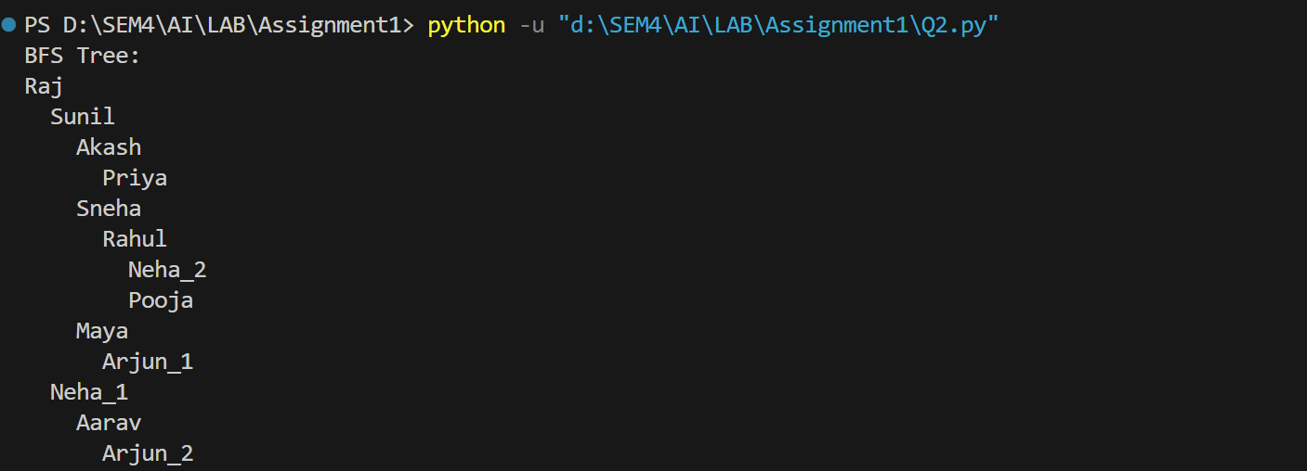

DFS:
graph = {
"Raj": ["Sunil", "Neha_1"],
"Sunil": ["Raj", "Akash", "Sneha", "Maya"],
"Akash": ["Sunil", "Priya"],
"Priya": ["Raj", "Aarav", "Akash"],
"Neha_1": ["Raj", "Akash", "Sneha", "Aarav"],
"Sneha": ["Sunil", "Neha_1", "Rahul"],
"Maya": ["Rahul", "Arjun_1", "Sunil"],
"Aarav": ["Neha_1", "Arjun_2"],
"Neha_2": ["Priya", "Neha_1", "Rahul", "Arjun_2"],
"Rahul": ["Neha_1", "Neha_2", "Sneha", "Maya", "Pooja", "Arjun_2"],
"Arjun_1": ["Maya", "Pooja"],
"Arjun_2": ["Aarav", "Neha_2", "Rahul"],
"Pooja": ["Arjun_1", "Arjun_2", "Rahul"]
}

def print_tree(parent, node, level=0):
print(" " * level + node)
for child in parent:
if parent[child] == node:
print_tree(parent, child, level + 1)

#DFS
def dfs_tree(graph, node, visited, parent):
visited.add(node)
for neighbor in graph[node]:
if neighbor not in visited:
parent[neighbor] = node
dfs_tree(graph, neighbor, visited, parent)
return parent

visited = set()
parent = {"Raj": None}

dfs_tree(graph, "Raj", visited, parent)

print("DFS Tree:")
print_tree(parent, "Raj")

